

**Embry-Riddle Aeronautical University**

Prescott, Arizona

College of Engineering

Embry-Riddle Hydrogen

Hannah Spiller, Design Team Lead

Tesla Alford III

Dylan Astrup

Titan Berson

Grant Carrabine

Jacob Wolf

**Abstract**

The education of hydrogen production and storage is crucial to the potential future of the hydrogen economy. To accomplish the goal of hydrogen education, we propose a PEM electrolyzer and nickel mesh as well as material-based storage using graphitic carbon nitride. The cost of the system will be approximately $1800 and run at 22.89 Amps producing 0.0142 grams of hydrogen per minute. The electrolysis unit will have a view to the internals in order to increase the educational value of the project. The discussed design also includes a clear portable reservoir containing the graphitic carbon nitride, allowing the storage method to be viewable to an audience. The proposed design is a safe and educational method to introduce students and the general public to hydrogen production and storage.

**Table of Contents**

Nomenclature 5

List of Figures 6

List of Tables 7

Mission Statement 8

Critical Requirements Overview 8

Purpose 8

Benefits 8

System Concept 8

Objectives 8

Concept of Operations 8

Electrolysis 10

Material-based Storage 12

Fuel Cell 12

Requirement Fulfillment 12

Potential Risks 13

Similar Systems 13

Hydrogen Generation 13

Microbial Biomass Conversion 14

Photobiological 14

The Shared Issues with Biology 14

Electrolysis 15

Steam-Methane Reforming 15

Hydrogen Storage 15

Physical Based 15

Material Based 15

Trade Studies 16

Electrolysis 16

Alkaline 16

PEM 16

Solid Oxide 16

Material Storage 17

Metal Hydrides 17

Intermetallic hydrides 17

Chemical Hydrides 17

Carbon Nitrides 17

Project Impact 18

Budget 18

Schedule 19

Conclusion 19

Acknowledgements 20

References 21

Appendix 22

Appendix A: Requirements 22

Appendix B: Organization Chart 23

Appendix C: Equations 24

Appendix D: Gantt Chart 25

# Nomenclature

DTL = Design Team Lead

MBC = Microbial Biomass Conversion

PBS = Photobiological systems

PEM = Proton Exchange Membrane

H2 = Hydrogen gas

SMR = Steam-Methane Reforming

EyRIE = Energy Research and Interactive Experimentation

# List of Figures

Figure 1: EyRIE Lab Layout 9

Figure 2: PFD of Proposed System 9

Figure 3: Electrolysis Unit 10

Figure 4: Electrolysis Unit, Exploded View 11

Figure 5: Requirement Matrix 13

Figure 6: Schedule for August-October 25

Figure 7: Schedule for November 26

Figure 8: Schedule for Build 27

# List of Tables

Table 1: Generation Pugh Matrix 12

Table 2: Storage Pugh Matrix 12

Table 3: Team Budget 18

Table 4: Team Schedule 19

# Mission Statement

Safely bring demonstration-scale hydrogen generation and storage to Embry-Riddle Prescott campus to inform and inspire future engineers on the development of alternative energy sources.

## Critical Requirements Overview

The proposed design meets all functional and educational requirements. It will produce at least 0.02 grams of hydrogen to run the fuel cell and it will store 0.04 grams of hydrogen. The storage mechanism of the material can store hydrogen safely at ambient conditions. The power input can be easily transferred from DC power to an alternative source, and the process of material storage is visible and interactive with the public.

Purpose

To generate and store hydrogen to power a fuel cell as a demonstrator to educate the population of Embry-Riddle Prescott about hydrogen as an alternative fuel source and the use of material storage.

Benefits

This proposed design is affordable, innovative, and demonstrates the use and storage of hydrogen as a fuel. Electrolysis is scalable to this smaller application, while still being effective in producing sufficient amounts of hydrogen. The material storage element is an exciting new way to store the hydrogen that does not require compression and is portable. Using this material is a great demonstrator because it is visible and safe for interaction with the public.

# System Concept

## Objectives

Our system will produce and store hydrogen to demonstrate how hydrogen can be used to store energy. This will be done by producing and storing sufficient hydrogen in material-based storage to run the existing fuel cell for 10 minutes at 1 watt.

## Concept of Operations

The system utilized distilled water and electricity as the only inputs. The distilled water is then transferred into a storage container for use by the electrolysis device. The electrolysis device then separates provided water into hydrogen and oxygen gas. Hydrogen gas is channeled into a sealed flask and captured by our material-based storage, graphitic-carbon nitride. Once sufficient hydrogen is channeled into the flask, the electrolysis device is turned off. Then the flask is taken to a Bunsen burner and heated to 300°C. When heated, graphitic-carbon nitride releases the captured hydrogen. That hydrogen is then funneled to other systems throughout the EyRIE (Energy Research and Interactive Experimentation) Lab illustrated in Figure 1 for use.

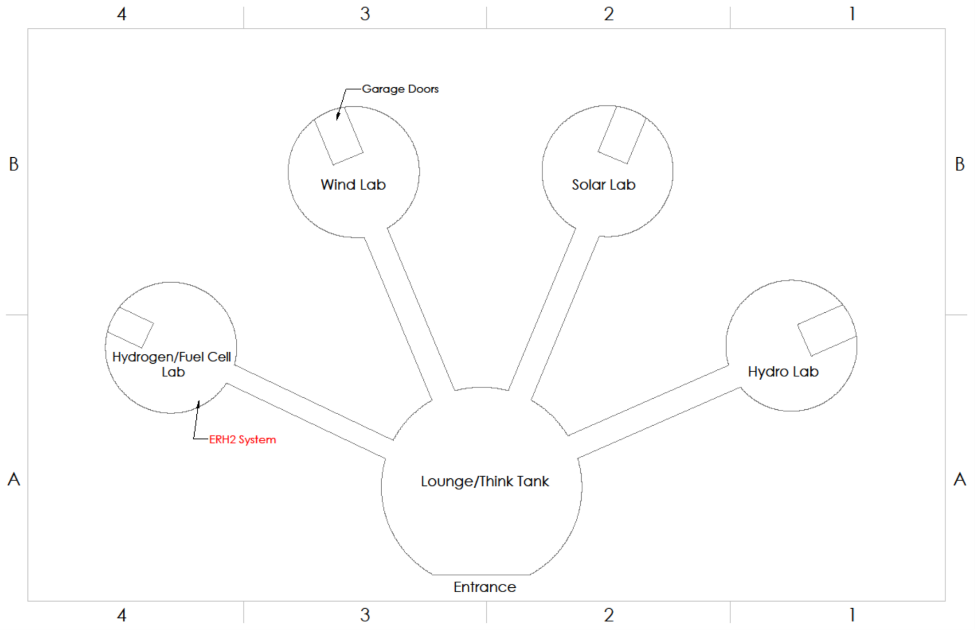

Figure 1: EyRIE Lab Layout

This could be used in a fuel cell or for other demonstration methods.

Our system will consist of three major components: the electrolysis unit, material-based storage, and the fuel cell.

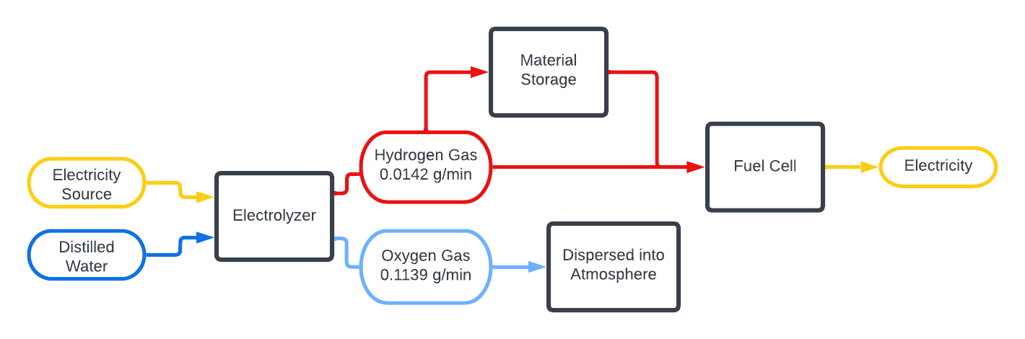

Figure 2: PFD of Proposed System

### Electrolysis

Electrolysis will be used to create enough hydrogen to be able to run the fuel cell. The fuel cell needs 0.02 grams of hydrogen to run the fuel cell for ten minutes. The electrolyzer, illustrated in Figures 3 and 4, will use a PEM design consisting of a cathode and anode made of nickel mesh separated by a membrane. The membrane keeps the hydrogen and the oxygen separate, and tubes take the hydrogen to the fuel cell or the material-based storage while the oxygen is vented.

Figure 3: Electrolysis Unit

Membrane

Nickel Mesh

Figure 4: Electrolysis Unit, Exploded View

### Material-based Storage

Graphitic-carbon nitride will be used to store the produced hydrogen for future use. The solid storage will be made using urea, sugar, and sufficient heat to create graphitic-carbon nitride. This material holds the hydrogen by absorption when the hydrogen is added to the material at ambient conditions. The graphitic carbon nitride holds ~10% mass of hydrogen and is only released when it is heated to 300°C.

### Fuel Cell

The fuel cell will be provided by the school and demonstrate that hydrogen can be used to create electricity. This will either be connected directly to the electrolysis unit or the solid storage to generate power.

## Requirement Fulfillment

Requirements 1.1 and 1.1.1 state that ERH2 demonstrator will produce 0.02 grams of H2. Using a PEM electrolyzer, ERH2 exceeds the requirements, with maximum H2 production at 0.142 grams of H2 in 10 minutes. Requirement 1.3 requires that the system will run off DC power. The planned PEM electrolyzer will run on DC power by a battery.

Table 1: Generation Pugh Matrix

|  |  |  |  |  |
| --- | --- | --- | --- | --- |
| **GENERATION** | **Weighting** | **SMR (Datum)** | **Biological** | **Electrolysis** |
| Cost | 1 | - | -1 | 1 |
| Production rate | 2 | - | -1 | -1 |
| System efficiency | 3 | - | -1 | 1 |
| Total |  | - | -5 | 2 |

Requirement 1.2 states that the system must store 0.04 grams of H2. Using the Graphitic-carbon nitride material storage, ERH2 planned demonstration can be scaled to hold the required amount of H2.

Table 2: Storage Pugh Matrix

|  |  |  |  |  |  |  |
| --- | --- | --- | --- | --- | --- | --- |
| **STORAGE** | **Weighting** | **Physical (Datum)** | **Metal Hydride** | **Intermetallic Hydride** | **Chemical Hydride** | **Carbon Nitride** |
| Cost | 2 | - | 1 | 1 | 1 | 1 |
| Capacity | 3 | - | -1 | -1 | -1 | 1 |
| Discharge rate | 1 | - | -1 | 1 | 1 | -1 |
| Total |  | - | -2 | 0 | 0 | 4 |

Both the material storage and the Electrolysis system meet requirements in 2.0, 3.0, 4.0, and 5.0. Requirements 2.0 states that the system must follow Embry-Riddle’s safety guidelines. All ERH2 members will take the online training course before taking detail in the spring of 2023. Requirements 3.0 states that the system must be used in an educational setting. Both systems can be easily activated and visible for learning purposes. Requirements 4.0 is performance measurements, which ERH2’s planned system will follow. The electrolysis subsystem produces 0.142 grams of H2 in a 10-minute period, which enough to run the fuel cell and store on the material storage. We plan to make enough material storage to hold all the H2 produced. Requirements 5.0 states that smallest human factors will be accounted for. The planned subsystems will account for any needed human factor interfaces.

Our requirement matrix shown below, highlights all of the requirements in the request for proposals that is fulfilled in each step of our design.

Figure 5: Requirement Matrix

The Design elements v Requirements matrix goes through each requirement and which components address each requirement.

# Potential Risks

Since hydrogen is such a small molecule, it is difficult to keep it contained within a system. Hydrogen is also extremely flammable so it is possible that escaped hydrogen could become a fire hazard. The team will address this risk by having tight seals, one-way valves to prevent backflow, and storing the hydrogen in a stable material that has a tight hold on the hydrogen. Since this material absorbs hydrogen, it does not present a fire hazard when absorbed in material. When the hydrogen is extracted from the material, it will be in a sealed container protected from ignition sources.

# Similar Systems

## Hydrogen Generation

ERH2 has conducted research on ways to generate hydrogen (H2) gas to fulfill the requirements of our demonstrator system.

### Microbial Biomass Conversion

Microbial Biomass Conversion (MBC) uses fermentation processes with either bacteria or fungal spores that break down hydrocarbons to produce H2 gas. The US Department of Energy has been conducting experiments on MBC systems for both renewable generation and for waste management options. One current application has been in sewage and wastewater treatment plants. The MBC bacteria have been employed to break down the “wastewater slurry” into products such as methane gas. With the gases free, plants can feed the gas into a Brayton cycle natural gas turbine system to produce power. This does still emit carbon dioxide into the atmosphere, however unlike unfiltered coal burning, the system will not produce sulfuric oxide (SOx) and nitrous oxide (NOx) as biproducts. Currently MBC is not used for H2 gas production directly, but there are plans to use two or more bacteria strains or fungal spores to convert the methane gas into H2 gas.

ERH2 investigated MBC because it seemed simple to have bacteria passively break down wastewater into H2 gas. One benefit from MBC is the lack of complexity for the breakdown process, however it brings its own challenges in collecting the hydrogen from the bacteria. During a fermentation process, the bacteria typically consume some of the elements, such as the hydrogen we are trying to get. This leads to a “race” to collect the H2 gas before the bacteria can consume it. As it currently stands, there is no way to collect all the H2 gas generated from this process. Because of this, the net efficiency of MBC systems is low and varies heavily from the strains of bacteria chosen. Another issue with MBC systems is the production rates of H2 gas in each period. Some data of MBC production rates have shown that at best an MBC system can produce 1.6 liters of H2 over a 10-day period.[1] When talking to Dr. Eaton about using the MBC system for H2 gas generation, one major part ERH2 would need to employ is a bioreactor. A bioreactor is an apparatus that conducts artificial biological reactions. Embry-Riddle does not have one of these systems on hand and would require one that is certified for lab use in order to apply it to ERH2s planned design. With the complexity in design for a bioreactor, ERH2 could not build a unit in a semester timeframe. This would also limit the system to remain indoors, since bioreactors do not work in an outdoor conditions. [2], [3]

### Photobiological

Similar to MBC, photobiological systems (PBS) uses bacteria that breaks down water into H2 gas. Instead of fermentation, PBS uses microorganisms such as microalgae or cyanobacteria, that take in sunlight and split water into oxygen (O2) and H2 gas. PBS faces similar issues to MBC, with the only difference being PBS can be outside since it uses sunlight to function. Because of this, PBS also produces hydrogen very slowly and can only produce when sunlight is available.[4]

### The Shared Issues with Biology

With the biology route there are several shared benefits and issues. Beginning with production rates, both routes in fermentation (MBC) and photobiology (PBS), are known for being slow. Not just slow like a liter an hour, but slow like a liter in several days. This would be an issue for demonstration purposes, since ERH2 cannot demonstrate the functionality of the system over the course of a week. The next issue with biology regards determining which bacterial strain to use. The Earth houses one trillion types of bacteria and with that comes a challenge on deciding on the used bacteria. As it stands, there is no one appointed strain that is commercially selected as the “best”. Instead, biologists are still trying to find and/ or create the most “optimal” strain. From the multitude of possible strains of bacteria to choose from, along with adding the difficultly of obtaining the bacteria, this would lead to another issue for ERH2. Another issue that Dr. Eaton listed with a biology route, is a waste filtration system for the bacteria. After the bacteria has completed its cycle, there will be some-amount of waste that if left untreated, it will kill the bacteria. The bacteria will also need a properly regulated environment, meaning that the housing system will need to be thermally controlled within one degree Celsius. These are some of the main reasons why ERH2 is not using biology to produce the hydrogen gas. [2]

### Electrolysis

Electrolysis has been utilized for H2 gas generation for several decades. Electrolysis uses an electrical current to apply a charge to a water molecule. Now charged with an added electron, the water molecule separates into H2 gas and O2 gas. All electrolysis systems have three main components: the electrolyte, the anode, and the cathode. As of now, there are three main types of electrolysis systems in use: polymer electrolyte membrane (PEM), alkaline, and solid oxide.

### Steam-Methane Reforming

Steam-Methane Reforming (SMR) is the most popular system for H2 production in the United States. SMR is commonly used because of the availability of methane gas, also known as natural gas. It uses high temperature steam (700-1000°C) that bonds to methane gas when mixed, leaving behind H2, CO and small amounts of CO2. SMR requires sources of methane gas and access to high temperature steam to be effective. Because of this, ERH2 decided not to use SMR for the generation of H2.

## Hydrogen Storage

ERH2 has conducted research on ways to store H2 gas to fulfill the requirements of our demonstrator system.

### Physical Based

One possible way ERH2 investigated storing H2 gas is through physical storage. Physical storage consists of compressed gas, cold/cryo, and liquid H2. Even though physical storage works well for most gases, such as propane, oxygen, and refrigerants, however for hydrogen physical storage is hard. H2 is the smallest atomic bond in the known universe, this makes storing it difficult since compressing a very small amount of it takes a lot of energy. The other way to store hydrogen in a physical state is through extreme temperature control. To achieve liquid hydrogen, a temperature of -253°C and for solid state a temperature of -259°C. This all lead to several issues for ERH2 when designing a storage system within an effective cost range. Since compressors are expensive and the university does not have the ability to cool down the H2 gas to almost absolute zero conditions, ERH2 will have to look elsewhere for storage. [5]

### Material Based

H2 can also be stored inside other compounds either through adsorption or absorption. Using a series of compounds, H2 gas can be stored and easily used without needing compression and low temperature systems. This is a highly sought-after approach; however, it requires a magnitude of research dedicated in chemical research. ERH2 is looking into a material storage approach using urea and granulated sugar to act as the binding material. When H2 is exposed to the urea-sugar combination, the H2 will become “trapped” inside the compound “powder”. Once stored, the H2 gas can be accessed by heating the compound powder to 300°C.

# Trade Studies

## Electrolysis

Electrolysis is the process of using electrical current to “rip apart” a wat er molecule (H2O) and split it into 2 H+ and a O. Electrolysis has been used to split water molecules since 1800, however large-scale hydrogen production, such as through electrolysis, has been slowly growing in todays (2022) market. Electrolyzer are assembled via several different ways; Proton Exchange Membrane (PEM), Alkaline, and Solid Oxide. The following paragraphs will go further into detail on how the listed systems work and the associated challenges with them.

### Alkaline

The conventional alkaline is the most common type of electrolyzer and has had several decades of research associated with the improvement of efficiency, production rates, and safety. The classic alkaline is a unipolar design often using iron or nickel as the electrode and an aqueous electrolyte solution like potassium hydroxide (KOH) flowing over the electrode. Once the electrode is powered by direct current (DC), water can flow through the anode while contacting the powered electrolyte. When the water contacts the electrolyte, the water molecule will split, sending positively charged hydrogen (H+) to the cathode side. The H+ ions will bond in pairs becoming H2 and leave the cathode. Issues with the conventional alkaline can be from the total system efficiency and low production rates of hydrogen gas. On average conventional alkaline systems can have a net efficiency of 70% while taking around 55 kWh to produce 1 kg of H2.  [6], [7]

### PEM

Unlike conventional alkaline, PEM electrolysis uses a solid polymer membrane usually made from Nafion. This leads to a higher efficiency at H2 production at 84% round trip and using on average 50 kWh of energy. One of the major disadvantages of PEM is the cost. A PEM electrolyzer can cost anywhere from double to almost triple the amount as an alkaline electrolyzer. Most of this increase in cost can be associated in the Nafion itself, this leads to the overall price of a PEM electrolyzer dependent on the size of the membrane. ERH2 is planning on using a PEM membrane for the electrolysis sub-system. The currently planned membrane will be a Nafion 10 X 10 cm MEA 3 layer, at $472.00 (not including shipping and taxes). [6], [8]

### Solid Oxide

Solid Oxide electrolysis requires the ceramic electrolyte to be at a temperature range of 700°C - 800°C. There is a fair amount of research in solid oxide electrolysis for laboratory purposes, however for a capstone demonstration, solid oxide would prove to be more challenging to implement compared to a PEM or alkaline system. One such issue would be achieving the needed temperature range and maintaining it long enough for demonstration. [7]

## Material Storage

Hydrogen material storage is a method of storing hydrogen in within solid materials. This process is highly efficient since the material absorbs the H2 and then can be stored at ambient conditions until release is necessary. The absorption and extraction process are different for every material, and along with the H2 weight percentage capacity and cost of material, determine the value of each material and how we decided which material would be the best for our application.

### Metal Hydrides

Metal hydrides utilize a host metal to chemically bond hydrogen to for storage. Elemental metal hydrides most promising for hydrogen storage are magnesium and aluminum hydrides with capacities of 7.6% (wt.) and 10.1% (wt.) respectively. Magnesium hydride displays sluggish kinetics during both hydrogenation and dehydrogenation, requiring temperatures exceeding 300℃ to achieve a reasonable charge and discharge rate. Aluminum hydride creates weaker bonds than magnesium resulting in much lower temperatures (100℃) for reasonable discharge. However, aluminum hydride requires extreme pressures and temperatures for formation (1450ksi and 600℃) making their use unreasonable. [9], [10]

### Intermetallic hydrides

The proposed idea behind the use of intermetallic hydrides is that an element that binds hydrogen strongly and an element that binds hydrogen weakly are both included in an alloy. The alloys storage abilities vary based of the choice of the two elements in addition to the ratio of the two elements. Unfortunately, most intermetallic hydrides have hydrogen storage capacities of less than 2% (wt.). In addition to the low storage capacity, these materials are often very expensive, such as TiFe costing more than $367/kg. Although they have been successfully used in industry, intermetallic hydrides are very costly and lack sufficient storage capacity making them unreasonable for our application. [9]

### Chemical Hydrides

Chemical hydrides are similar to the metal hydrides since they also chemically bond to the hydrogen, but they are often liquids at standard conditions. This simplifies their storage and transportation. In addition, many of the chemicals that can store hydrogen already have the required production and infrastructure built around them, such as methanol and ammonia. Methanol and Ammonia both have high hydrogen storage capacities of 12.5% (wt.) and 17.7% (wt.), respectively. But both of these chemicals need high temperature and pressure in order to absorb and bond with the hydrogen. This makes them impractical when compared to other materials that bond with hydrogen at ambient conditions and only require high temperature when extracting. [9]

### Carbon Nitrides

Carbon nitrides, specifically graphitic-carbon nitrides (g-C3N4), are promising candidates for hydrogen storage due to their high surface area and high levels of active sites for ion bonding. As a result, research has been conducted in modifications for this material to increase its storage capacity. Unmodified g-C3N4 can store around 1.5% (wt.) however when doped with metals such as lithium which increases the storage capacity to >10% (wt.). Compare this to current pressurized tank storage which exhibits capacities of 5-6% (wt.) and raises major safety concerns with flammable gases pressurized to 5,000psi or more. When heated to 300℃ at atmospheric pressure the materials release stored hydrogen for use in other systems. [11]

# Project Impact

The adoption of our hydrogen generation and storage system will support future development towards a society powered by clean energy. As a demonstrator our system will increase public knowledge and interest in these emerging technologies, particularly interest from young, aspiring engineers. Institutionally this will be a great resource for all engineering departments at Embry-Riddle. The departments can expect to see increased enrollment and infrastructure development as more projects stem from this system ranging from smart electrical grids to advanced hydrogen engines and satellite fuel cells.

# Budget

Review table 1 for the core-component and sub-system budget. For individual costs, refer to the team finances excel document.

Table 3: Team Budget

|  |  |  |
| --- | --- | --- |
| **INCOME** |  |  |
|  | Base | $1,300.00 |
|  | **TOTAL INCOME** | $1,300.00 |
| **EXPENSES** |  |  |
|  | Electrolysis | $675.00 |
|  | Material Storage | $230.00 |
|  | Charge/Discharge | $87.00 |
|  | Plumbing | $24.00 |
|  | Instrumentation | $400.00 |
|  | Valves | $80.00 |
|  | Sealant | $30.00 |
|  | Electrical | $30.00 |
|  | Team Shirts | $80.00 |
|  | **TOTAL EXPENSES** | $1,636.00 |
| **TOTAL** |  | $(336.00) |

Currently the system is $336 overbudget. This is because we used extremely conservative estimates for all our expenses and set aside money for systems that will likely be provided by Embry-Riddle. The team plans to apply for a $1000 grant through Embry-Riddle to further support the project.

# Schedule

Table 4: Team Schedule

|  |  |  |
| --- | --- | --- |
| **Task** | **Start Date** | **End Date** |
| Build Electrolysis | 2/13/2023 | 3/3/2023 |
| Assemble Plumbing | 3/6/2023 | 3/20/2023 |
| Valves and Seals | 3/20/2023 | 3/31/2023 |
| Final Report | 2/15/2023 | 4/28/2023 |

It is expected to take around 6 weeks to build the system. To complete the electrolysis machine, it will take three weeks, the piping of the system will take 2 weeks, and checking the valves and seals will take 1 week. Throughout the process, the team will be documenting the progress and writing the report due the 28th of April. All Gantt charts for fall and spring can be found in appendix D.

Once the system is complete, it will be an installment into the EyRIE Lab. Since the EyRIE Lab is not built yet, the system will go into the care of the college of Engineering. The system will be compact enough to be easily stored in a closet or put on display in an engineering building until the EyRIE Lab is complete. The overseer of the system will be the chair of the college of engineering and/or the chair of the energy department within the college of engineering.

# Conclusion

Our design prioritizes all the listed requirements that have been requested. We will use an electrolysis unit to demonstrate and educate on the process of hydrogen generation because of its wide industry adoption and the ease of viewing the generation process. Our design also includes material hydrogen storage, a revolutionary method of hydrogen storage that will benefit both the educational possibilities as well as the overall system efficiency. Therefore, our hydrogen generation and storage design is the best suited for the provided requirements, exceeding the minimum educational, efficiency, and safety requirements providing the best possible product for your application.

# Acknowledgements

Dr. Karl Heine

Dr. Johnathan Adams

Dr. Richard DiPietro

Dr. Hillary Eaton

Professor Rachel Schmidt

Dr. Istemi Ozsoy

Dr. David Lanning

Dr. Robert Murray-Smith

AXFAB Staff

# References

[1] S. Wang *et al.*, “Metabolite-based mutualism enhances hydrogen production in a two-species microbial consortium,” *Commun. Biol.*, vol. 2, no. 1, p. 82, Dec. 2019, doi: 10.1038/s42003-019-0331-8.

[2] Eaton, Hillary, “Conversation with Dr. Eaton,” Sep. 12, 2022.

[3] “Hydrogen Production: Microbial Biomass Conversion,” *Energy.gov*. https://www.energy.gov/eere/fuelcells/hydrogen-production-microbial-biomass-conversion (accessed Sep. 19, 2022).

[4] “Hydrogen Production: Photobiological,” *Energy.gov*. https://www.energy.gov/eere/fuelcells/hydrogen-production-photobiological (accessed Sep. 19, 2022).

[5] “Hydrogen Storage,” *Energy.gov*. https://www.energy.gov/eere/fuelcells/hydrogen-storage (accessed Sep. 19, 2022).

[6] G. T.d, M. A.d, S. D. Lj, and U. B, “COMPARISON OF ALKALINE AND PROTON EXCHANGE MEMBRANE ELECTROLYZERS,” *Журнал Физической Химии*, vol. 82, no. 11, 2008, Accessed: Sep. 26, 2022. [Online]. Available: http://naukarus.com/comparison-of-alkaline-and-proton-exchange-membrane-electrolyzers

[7] “Hydrogen Production: Electrolysis,” *Energy.gov*. https://www.energy.gov/eere/fuelcells/hydrogen-production-electrolysis (accessed Sep. 19, 2022).

[8] Z. Zakaria and S. K. Kamarudin, “A review of alkaline solid polymer membrane in the application of AEM electrolyzer: Materials and characterization,” *Int. J. Energy Res.*, vol. 45, no. 13, pp. 18337–18354, Oct. 2021, doi: 10.1002/er.6983.

[9] J. Andersson and S. Grönkvist, “Large-scale storage of hydrogen,” *Int. J. Hydrog. Energy*, vol. 44, no. 23, pp. 11901–11919, May 2019, doi: 10.1016/j.ijhydene.2019.03.063.

[10] H. Saitoh, Y. Sakurai, A. Machida, Y. Katayama, and K. Aoki, “*In situ* X-ray diffraction measurement of the hydrogenation and dehydrogenation of aluminum and characterization of the recovered AlH 3,” *J. Phys. Conf. Ser.*, vol. 215, p. 012127, Mar. 2010, doi: 10.1088/1742-6596/215/1/012127.

[11] A. Murali, M. Sakar, S. Priya, R. J. Bensingh, and M. A. Kader, “Graphitic-Carbon Nitride for Hydrogen Storage,” in *Nanoscale Graphitic Carbon Nitride*, Elsevier, 2022, pp. 487–514. doi: 10.1016/B978-0-12-823034-3.00017-0.

# Appendix

## Appendix A: Requirements

**1.0 Function**

1.1 The system must produce hydrogen gas.

1.1.1 The system must produce 0.02 grams of hydrogen gas to run the fuel cell for 10 minutes at 1 watt.

1.2 The system must store 0.04 grams of hydrogen gas.

1.3 The system must use DC power to be able to use both alternative energy sources and battery power.

**2.0 Safety**

2.1 The system must allow for safe extraction of hydrogen gas without risk of major leaks.

2.2 The system must follow Embry-Riddle Prescott Campus’ safety requirements. https://myerauedu.sharepoint.com/teams/APPM/section-2/Pages/2-4-policy.aspx

**3.0 Educational**

3.1 The system must serve as an educational demonstrator or lab device for the student body of Embry Riddle Prescott campus.

3.1.1 The internal system components should be visible for educational purposes.

3.1.2.1 The system must display the approximate amount of hydrogen gas being produced.

3.1.2.2 The system must display the approximate amount of hydrogen gas stored.

3.1.3 The system must have a learning feature about the hydrogen economy and where it could go in the future.

3.1.4 The system must display all values used for demonstration purposes in English units.

**4.0 Performance**

4.1 The material storage efficiency (hydrogen in vs. Hydrogen out) must be at least 50%.

4.1.1 The fuel entering the system will produce hydrogen gas at 50%.

4.2 The system must include a proposed Energy Land layout.

4.2.1 The system must be movable.

4.3 The electrolysis unit to fuel cell system must be able to run for 20 minutes.

**5.0 Human Factor**

5.1 The system must operate in a room that has a fire/smoke alarm system if working indoors.

5.2 The system should be easy to operate by authorized users.

## Appendix B: Organization Chart

## Appendix C: Equations

Maximum Theoretical Current Requirement for Electrolyzer:

Rate of Hydrogen Production in Electrolyzer:

Rate of Oxygen Production in Electrolyzer:

Area of Mesh in Electrolyzer:

Hydrogen Required to Run the Fuel Cell for 10 Minutes at 1 Watt:

## Appendix D: Gantt Chart

Figure 6: Schedule for August-October

Figure 7: Schedule for November

Figure 8: Schedule for Build